Jenna Gensic
jennagensic@gmail.com
jennagensic@learnfromautistics.com
Twitter: @jennagensic
FB: @learnfromautistics

Author Bio
Jenna Gensic is a freelance writer, disability advocate, and mother of four from northern Indiana. Jenna has a BA in English and an MA in English writing; she taught high school English before making the decision to work from home and raise her young children. She is the author of What Your Child on the Spectrum Really Needs: Advice from 12 Autistic Adults and manages the Learn from Autistics website (learnfromautistics.com), and writes and speaks about parenting issues related to prematurity, cerebral palsy, and autism. She is currently coauthoring a book on autism advocacy advice from the #ActuallyAutistic community.

Photos
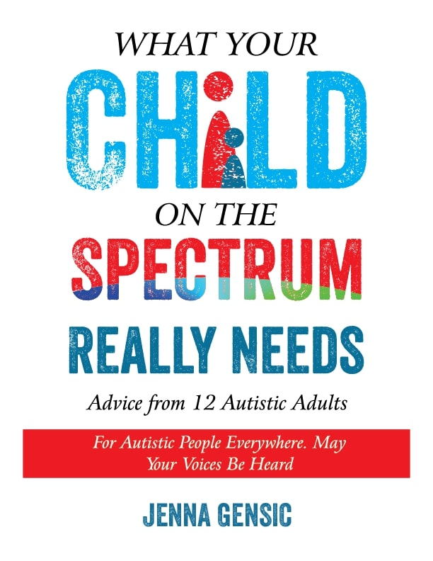

Press Release
FOR IMMEDIATE RELEASE

Jenna Gensic
jennagensic@gmail.com

New Parenting Book of #ActuallyAutistic Advice Calls Into Question What’s “Best” For Your Autistic Child

SHAWNEE, KS October 1, 2019 – What Your Child on the Spectrum Really Needs: Advice From 12 Adult Autistics is a new kind of parenting guidebook. What if the advice you've been given about raising your autistic child wasn’t accurate? What if the experts you had consulted and the research you had conducted missed glaring, fundamental insights into raising a happy, healthy child?

Twelve adults on the spectrum discuss what helped or hurt their development over the years. The book’s advice is based solely on the advice of actually autistic people and identifies some instances where the parents’ pursuit for what is “best” for their children may not align with positive identity development and adult success. It also teaches parents a better course of action for achieving these goals. Most surprising was the simple, practical guidelines the contributors offered for treating them with dignity and respect that are so often overlooked by neurotypical parents and caregivers.

Some topics include:
- Redefining communication breakdowns
- Discovering and supporting your child’s agenda
- Sensory Processing Disorder
- Behavioral therapies
- Encouraging self-advocacy and autism acceptance
- The problem with hiding autism
- Pursuing meaningful friendships (for you and your child)
- Educational advocacy
- Autistic success in the workplace

Author Jenna Gensic has a sincere respect for the authority of personal experience and a special interest in storytelling. She manages the Learn From Autistics website which regularly interviews autistic people and serves as a platform for autistic voices. This book, along with the Learn From Autistics website celebrate autistic expertise, neurodiversity, and autism acceptance.

What Your Child on the Spectrum Really Needs: Advice From 12 Adult Autistics can be purchased at… Follow Jenna’s advocacy work by visiting the Learn From Autistics blog, like the Learn From Autistics Facebook page, or follow her on Twitter @jennagensic.

Speaking topics
- Neurodiversity 101: Tips for promoting autism acceptance and raising more confident, capable Autistic children (advice from the #ActuallyAutistic community)
- Beginning steps to shifting your “expert” focus
- #ActuallyAutistic advice for educators/pre-service teachers

Book Summary
What Your Child on the Spectrum Really Needs: Advice From 12 Adult Autistics is a new kind of parenting guidebook Twelve adults on the spectrum discuss what helped or hurt their development over the years. The book’s advice is based solely on the advice of actually autistic people and identifies some instances where the parents’ pursuit for what is “best” for their children may not align with positive identity development and adult success. It also teaches parents a better course of action for achieving these goals. Most surprising was the simple, practical guidelines for they offered for treating them with dignity and respect that are so often overlooked by neurotypical parents and caregivers.

Some topics include:
- Redefining communication breakdowns
- Discovering and supporting your child’s agenda
- Sensory Processing Disorder
- Behavioral therapies
- Encouraging self-advocacy and autism acceptance
- The problem with hiding autism
- Pursuing meaningful friendships (for you and your child)
- Educational advocacy
- Autistic success in the workplace

Sell Sheet

Title: What Your Child on the Spectrum Really Needs: Advice From 12 Autistic Adults

Author: Jenna Gensic

Genre: Autism Parenting
Price: $19.95
# of pages: 118

ISBN-10: 1942197535
ISBN-13: 978-1942197539
ASIN: B07YQKDM2M

Publication date: October 1, 2019

Synopsis: What Your Child on the Spectrum Really Needs: Advice From 12 Adult Autistics is a new kind of parenting guidebook Twelve adults on the spectrum discuss what helped or hurt their development over the years. The book’s advice is based solely on the advice of actually autistic people and identifies some instances where the parents’ pursuit for what is “best” for their children may not align with positive identity development and adult success. It also teaches parents a better course of action for achieving these goals. Most surprising was the simple, practical guidelines for they offered for treating them with dignity and respect that are so often overlooked by neurotypical parents and caregivers.

Formats available: Paperback, e-book (coming soon)

Available on: Amazon, Barnes & Noble, and 40,000 other distributors

Thumbnails

Testimonials / Reviews

“Wise advice from twelve older autistic people will help teenagers and young adults on the spectrum navigate life. Jenna Gensic’s book will also provide parents and professionals with great insights.”
–Temple Grandin, author of Thinking in Pictures, The Autistic Brain

"It's easy to forget that adults could not receive an autism diagnosis until the 1990s, and that as a result, autistic children and their parents couldn't benefit from the lived experiences of people on the spectrum.

Jenna Gensic's book marks a profound historical shift -- the beginning of an era when parents can turn to autistic adults, instead of only to neurotypical 'experts,' for advice on helping their kids navigate and learn to thrive in a world that is often confusing and overwhelming. Gensic has gathered a group of wise autistic elders to offer helpful and practical guidance on a broad array of subjects and challenges. An uplifting and encouraging book."

-- Steve Silberman, author, NeuroTribes: The Legacy of Autism and the Future of Neurodiversity

"Jenna goes directly to the source – autistic people themselves – to gain greater understanding in what children on the spectrum need. Carefully crafted interviewing gifts the reader with vital insights in promoting fulfilling and productive lives for autistic children by working with their strengths, while remaining realistic about the often significant challenges, that come from being autistic."

--Stephen M. Shore, Ed.D, Internationally known educator, author, consultant, and presenter on issues related to autism

“In her book,What Your Child on the Spectrum Really Needs: Advice From 12 Autistic Adults, Jenna Gensic insightfully explores various angles of autism through interviews and reflection. I thoroughly enjoyed the perspective deep within our spectrum community--those with autism themselves. It is well-written, and very informative.”

-- Carrie Cariello, author, What Color is Monday?, Someone I’m With Has Autism

“This book is very important! One of the questions that I am asked most frequently by parents is, ‘How do I parent my child with autism so that he can excel?’ What Your Child Really Needs: Advice From 12 Autistic Adults provides the best insight into answering this question. Autistic adults share valuable information, stories, and tips that brilliantly illustrate how to help children experience life’s triumphs and overcome obstacles that may be placed in their way. Parents, please read this book!!”

-- Brenda Smith Myles, PhD, author, Excelling with Autism: Obtaining Critical Mass Using Deliberate Practice, The Hidden Curriculum: Practical Solutions for Understanding Unstated Rules in Social Situations

“There is a revolution underway that is deconstructing damaging myths, and reconstructing more positive and accurate understandings about the autistic experience. Indisputably, the leaders of this revolution are autistic people who have generously shared their first hand experiences. In this essential work, Jenna Gensic, a parent-professional and originator of the LearnfromAutistics.com website, draws from the experience and expertise of 12 autistic adults to take it a step further by offering direct advice for parents and family members. Jenna is to be congratulated for supporting more autistic voices in helping us better understand, support and appreciate the uniqueness autistic children and adults.”

--Barry M. Prizant, Ph.D., CCC-SLP, Adjunct Professor, Brown University, author, Uniquely Human: A Different Way of Seeing Autism and The SCERTS Model

"Jenna Gensic has written a book that is a must-read for future and current speech-language pathologists, parents of Autistics, and anyone else who wants an inside look at autism. Read this book and learn from the experts themselves-Autistics. She writes from an angle that does not alienate professionals, yet empowers parents and Autistics themselves. As a professor and speech-language pathologist of over 20 years, I highly recommend this book!"

--Jennifer M. Hatfield MHS CCC-SLP/L, Clinical Assistant Professor, Indiana University South Bend

